

**Foxtale**

**Product Dissection for Foxtale**

**Company Overview**

Foxtale is a rising D2C (Direct-to-Consumer) skincare brand launched in India, offering science-backed, dermatologically tested products designed for Indian skin types and climate. The brand focuses on transparency, simplicity, and effectiveness in skincare. Positioned uniquely in the beauty and wellness industry, Foxtale caters to the evolving needs of Gen Z and millennials, aiming to simplify skincare with targeted routines and clean formulations.

With a visually minimalist identity and a digital-first approach, Foxtale operates through its e-commerce website and has a strong presence on platforms like Instagram and Nykaa. It competes in a crowded skincare space by leveraging clinical claims, skin education, and customer-centric communication.

**Product Dissection and Real-World Problems Solved by Foxtale**

Foxtale addresses prevalent skincare challenges through innovation and clarity. It recognizes the confusion among Indian consumers caused by marketing jargon, over-complicated routines, and non-inclusive products. Its goal is to make skincare accessible, effective, and understandable.

**Key real-world challenges Foxtale addresses:**

* **Overwhelming Skincare Options:** The market is flooded with thousands of products with contradictory claims.
* **Lack of Ingredient Awareness:** Users often don't understand what ingredients are suitable for their skin type.
* **Skin Sensitivity to Climate:** Most skincare brands cater to western climates, not considering the humidity and pollution levels in India.
* **Lack of Routine Personalization:** Customers need clear routines tailored to their needs rather than isolated products.

**Foxtale’s Solutions:**

* **Curated Skincare Routines:** Customers can select routines based on skin concerns like acne, dryness, or dullness.
* **Ingredient Transparency:** The platform breaks down key ingredients like niacinamide, ceramides, and retinol in layman’s terms.
* **User-friendly Interface:** Simplified product pages with clear benefits, routines, and usage instructions.
* **Visual and Digital Accessibility:** Offers engaging social content, demo videos, and skin-type quizzes for personalized guidance.

**Case Study: Real-World Problems and Foxtale’s Solutions**

Foxtale bridges the gap between dermatological skincare and everyday users by providing a platform that is both educational and product-driven.

**Problem 1: Confusion Due to Skincare Jargon**

**Real-World Challenge:**  
Most users, especially beginners, find it hard to decode ingredient labels and match them to their skin concerns.

**Foxtale’s Solution:**

* Educates users with easy-to-read guides and skin blogs.
* Offers a skin quiz that recommends a routine based on skin goals and sensitivity.

**Problem 2: Inaccessibility to Effective Skincare in Tier-2/3 Cities**

**Real-World Challenge:**  
Quality skincare options are often limited outside major metros. Brick-and-mortar options may be unaffordable or outdated.

**Foxtale’s Solution:**

* Online-first presence ensures pan-India delivery.
* Affordable pricing makes premium skincare accessible to college students and young professionals.

**Problem 3: Uncertain Product Effectiveness and Trust**

**Real-World Challenge:**  
Users fear allergic reactions or poor results due to low product credibility or lack of trials.

**Foxtale’s Solution:**

* Clinically tested claims and dermatologically certified products.
* Offers return and trial options.
* Real customer reviews and before-after testimonials build confidence.

**Problem 4: Lack of Structured Routine Guidance**

**Real-World Challenge:**  
Users buy individual products without understanding how they fit into a complete routine.

**Foxtale’s Solution:**

* Ready-to-go AM/PM routines available on the website.
* Instructional videos on how to layer products correctly.

**Problem 5: Skin Type Diversity in India**

**Real-World Challenge:**  
One-size-fits-all skincare doesn't work with the diversity of Indian skin tones and types.

**Foxtale’s Solution:**

* Product lines formulated specifically for Indian conditions (humidity, tanning, pigmentation).
* Inclusive marketing showcases various skin tones and types.

**Top Features of Foxtale**

* **Skin Quiz and Routine Builder:** Guides customers to create personalized regimens.
* **Minimalist Packaging and UX:** Clean UI/UX on the website, product-focused design.
* **Ingredient Education:** Breakdowns of acids, retinoids, and hydrating agents.
* **Routine Bundles:** Curated kits like “Acne Control Kit” or “Hydration Pack.”
* **User Reviews and Results:** Verified reviews with customer stories.
* **Educational Blog & YouTube Channel:** Content-driven trust building.

**Schema Description**

The schema for Foxtale represents core entities required for a skincare D2C brand to manage users, products, transactions, routines, and feedback.

**Users Entity**

* **UserId** (Primary Key): Unique identifier for each user
* **Name**: Customer’s full name
* **Email**: Registered email
* **SkinType**: (Oily/Dry/Combination/Sensitive)
* **Location**: User’s city/state
* **SignUpDate**: Account creation date

**Products Entity**

* **ProductId** (Primary Key): Unique ID for each skincare product
* **ProductName**: Name of the product (e.g., Hydrating Cleanser)
* **Category**: Cleanser, Serum, Sunscreen, Moisturizer, etc.
* **Ingredients**: List of key ingredients
* **Price**: MRP of the product
* **SkinConcern**: Acne, Pigmentation, Dryness, etc.
* **IsActive**: Product status (active/inactive)

**Routine Entity**

* **RoutineId** (Primary Key): ID of skincare routine
* **SkinType**: Routine matched to skin type
* **StepOrder**: Cleanser (1), Serum (2), Moisturizer (3), etc.
* **ProductId** (FK): Product in the routine
* **RoutineType**: AM/PM

**Orders Entity**

* **OrderId** (Primary Key): Unique order ID
* **UserId** (FK): Customer who placed the order
* **ProductId** (FK): Product purchased
* **OrderDate**: Date of order
* **OrderStatus**: Placed, Shipped, Delivered
* **PaymentMethod**: UPI, Card, COD
* **AmountPaid**: Final price

**Review Entity**

* **ReviewId** (Primary Key): Unique ID for review
* **UserId** (FK): Who submitted it
* **ProductId** (FK): Product reviewed
* **Rating**: Out of 5
* **Comments**: Textual feedback
* **ReviewDate**: Date posted

**Enquiry Entity**

* **EnquiryId** (Primary Key): Unique ID for support query
* **UserId** (FK): Who raised the issue
* **Message**: Content of query
* **Status**: Open/Closed
* **CreatedDate**: When query was submitted

**Relationships Summary**

* **Users place Orders** — One user can place multiple orders.
* **Products belong to Routines** — Multiple products can exist in multiple routines.
* **Users review Products** — One user can write multiple reviews; each review belongs to one product.
* **Users raise Enquiries** — Each user can have multiple support requests.
* **Products relate to Skin Concerns and Types** — Helps in mapping routines and recommendations.

**ER-Diagram**

[This can be created using draw.io with entities such as Users, Products, Routines, Orders, Reviews, and Enquiries connected using relationships as described above.]

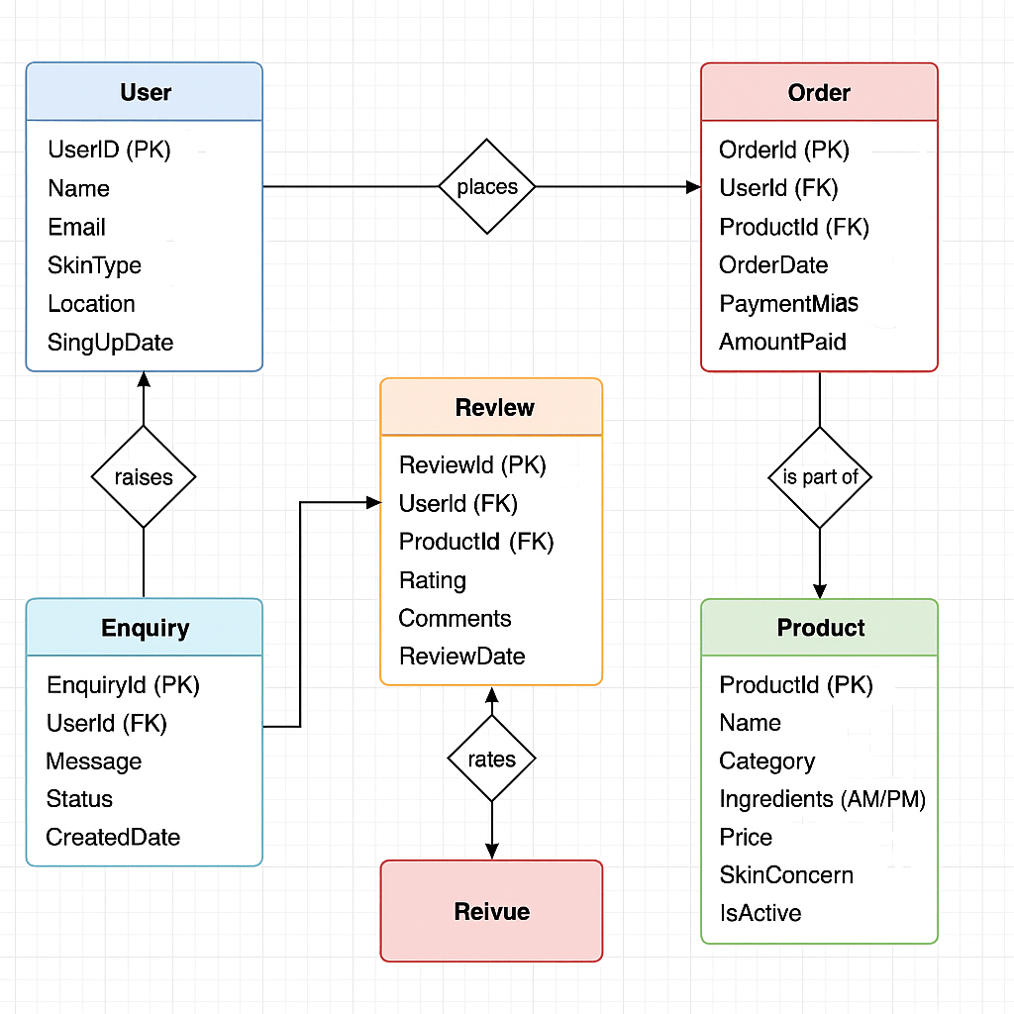

**Top-Rated and Most Popular Products of Foxtale**

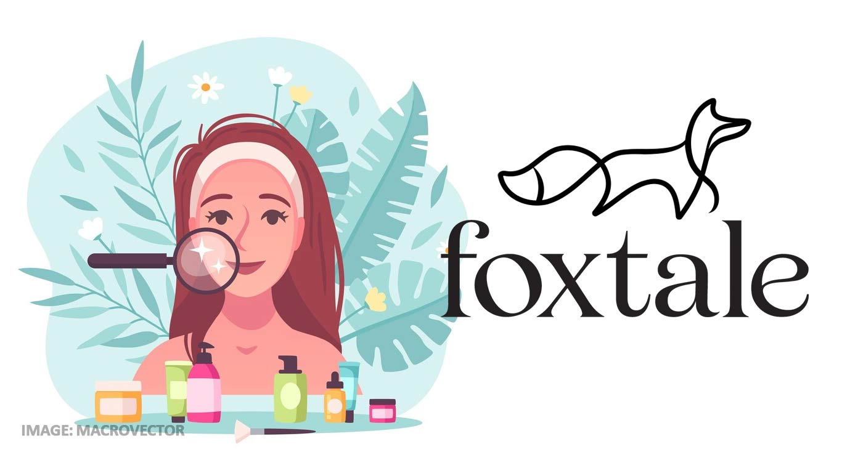

Foxtale has built its brand by offering clinically effective skincare products tailored for Indian skin types. The following are some of the **most popular and best-reviewed products** that have significantly contributed to Foxtale’s growth and user trust:

**1. The Daily Duet Cleanser**

* **Category:** Face Wash
* **Skin Type:** All skin types (especially oily and sensitive)
* **Key Ingredients:** Sodium PCA, Vitamin B5
* **Highlights:**
  + Gentle, non-stripping formula
  + Hydrating + barrier-protecting
  + Dermat-tested and fragrance-free
* **User Feedback:** Praised for its creamy texture and suitability for Indian humidity. Frequently recommended by dermatologists.

**2. Vitamin C Serum – Brightening and Hydrating**

* **Category:** Serum
* **Skin Type:** Dull, pigmented skin
* **Key Ingredients:** 15% L-Ascorbic Acid, Ferulic Acid, Vitamin E
* **Highlights:**
  + Reduces pigmentation and dark spots
  + Fast-absorbing, non-sticky
  + Safe for beginners and all skin tones
* **User Feedback:** One of the bestsellers; users report glow-up within 2–3 weeks of use.

**3. Cover-Up Sunscreen SPF 50 PA++++**

* **Category:** Sunscreen
* **Skin Type:** All skin types (especially acne-prone)
* **Key Ingredients:** Niacinamide, Vitamin E, Zinc Oxide
* **Highlights:**
  + Broad-spectrum protection
  + Lightweight and non-comedogenic
  + No white cast
* **User Feedback:** Highly rated for its texture and sweat-proof performance. Frequently sells out during summer sales.

**4. Ceramide Supercream Moisturizer**

* **Category:** Moisturizer
* **Skin Type:** Dry and sensitive
* **Key Ingredients:** Ceramides, Squalane, Panthenol
* **Highlights:**
  + Strengthens skin barrier
  + Deep hydration without clogging pores
  + Great for nighttime repair
* **User Feedback:** Loved for winter use and by users with eczema or damaged skin barriers.

**5. Acne Control Serum with Salicylic Acid**

* **Category:** Targeted treatment
* **Skin Type:** Oily and acne-prone
* **Key Ingredients:** 2% Salicylic Acid, Niacinamide
* **Highlights:**
  + Fights active breakouts and blackheads
  + Clears clogged pores
  + Reduces oil and redness
* **User Feedback:** Popular among teens and young adults; praised for fast results.

**📊 Impact of Popular Products on Platform Design**

These products are not only customer favorites but also shape **user flow and schema logic**:

* Each product is tagged under specific **SkinConcern** (e.g., acne, dullness).
* Bundles and routines are built using these bestsellers.
* Reviews for these products help drive UGC (user-generated content) and social proof.
* Replenishment rates and repeat orders for these products support loyalty-building features in the **Orders** entity schema.

**Conclusion**

Foxtale has innovatively responded to the needs of modern skincare users in India through transparency, education, personalization, and accessibility. With curated skincare routines, user-friendly interfaces, and dermatologically validated products, Foxtale solves key skincare problems across demographics and geographies. Its scalable schema and digital-first model ensure efficient operations, consistent user engagement, and long-term brand growth, placing it firmly among emerging leaders in India’s skincare landscape.